A000-Afr-Sorko Culture-Mermaid-Bronze-19th c

* 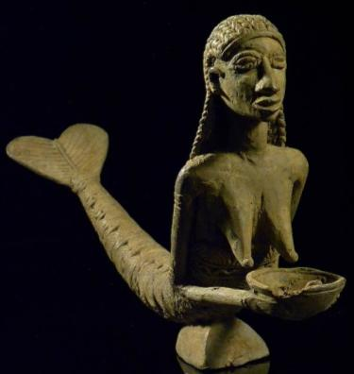 This Bronze figurine of a **mermaid** that may have its inspiration from the first Europeans who entered their area in the early sixteenth century. Based on the theme that the river was the source of life of the people just as was mother’s milk
* **Case no.:**
* **Accession Number:**
* **Formal Label:**
* **Display Description:**
* **LC Classification:**
* **Date or Time Horizon:**
* **Geographical Area:**
* **Map:**
* **GPS coordinates:**
* **Cultural Affiliation:**
* **Media:**
* **Dimensions:**
* **Weight:**
* **Condition:**
* **Provenance:**
* **Discussion:**
* **References:**
* This theme was then embodied in this unique example created by Sorko metal smiths using the lost wax process